Archaeological Inadvertent Discovery Plan (IDP)
[Markwardt Building Cleanup Phase I]
[Cathy Stuhr, City of Chiloquin] [November 8, 2023] [23-1470]

How to use this document

Archaeology consists of the physical remains of the activities of people in the past. This IDP should be followed should any archaeological sites, objects, or human remains are found. These are protected under Federal and State laws and their disturbance can result in criminal penalties.
This document pertains to the work of the Contractor, including any and all individuals, organizations, or companies associated with [Markwardt Building Cleanup Phase I].

What may be encountered
Archaeology can be found during any ground-disturbing activity. If encountered all excavation and work in the area MUST STOP. Archaeological objects vary and can include evidence or remnants of historic-era and precontact activities by humans. Archaeological objects can include but are not limited to:
  - Stone flakes, arrowheads, stone tools, bone or wooden tools, baskets, beads.
  - Historic building materials such as nails, glass, metal such as cans, barrel rings, farm implements, ceramics, bottles, marbles, beads.
  - Layers of discolored earth resulting from hearth fire
  - Structural remains such as foundations
  - Shell Middens
  - Human skeletal remains and/or bone fragments which may be whole or fragmented.
For photographic examples of artifacts, please see Appendix A. (Human remains not included)
If there is an inadvertent discovery of any archaeological objects see procedures below.
If in doubt call it in.

Discovery Procedures: What to do if you find something
  - Stop ALL work in the vicinity of the find
  - Secure and protect area of inadvertent discovery with 30 meter/100 foot buffer—work may continue outside of this buffer
  - Notify Project Manager and Agency Official
  - Project Manager will need to contact a professional archaeologist to assess the find.
  - If archaeologist determines the find is an archaeological site or object, contact SHPO. If it is determined to not be archaeological, you may continue work.

Human Remains Procedures
  - If it is believed the find may be human remains, stop ALL work.
  - Secure and protect area of inadvertent discovery with 30 meter/100 foot buffer, then work may continue outside of this buffer with caution.
  - Cover remains from view and protect them from damage or exposure, restrict access, and leave in place until directed otherwise. Do not take photographs. Do not speak to the media.
  - Notify:
    - Project Manager
    - Agency Official
    - Oregon State Police DO NOT CALL 911
    - SHPO
    - LCIS
    - Appropriate Native American Tribes
  - If the site is determined not to be a crime scene by the Oregon State Police, do not move anything! The remains will continue to be secured in place along with any associated funerary objects, and protected from weather, water runoff, and shielded from view.
  - Do not resume any work in the buffered area until a plan is developed and carried out between the State Police, SHPO, LCIS, and appropriate Native American Tribes and you are directed that work may proceed.

Contact Information
- Project Manager, [Cathy Stuhr, City of Chiloquin]: [503-702-4974]
- Agency Official, [Amy Baker, Region 10 EPA]: [206-499-8139]
- Contracted Archaeologist, [Dana Holschuh]: [503-944-9305]
- Oregon State Police, Lt. Craig Heuberger: 503-508-0779 cheuber@osp.oregon.gov
- Oregon State Historic Preservation Office (SHPO),
  - [SHPO archaeologist who reviewed submission]: [number]
  - Asst. State Archaeologist, John Pouley: 503-480-9164
  - GIS Archaeologist, Jamie French: 503-979-7580
- LCIS, Mitch Sparks: 503-986-1086
- Appropriate Tribes
[First Point of Contact for Tribal discoveries:
Christina Rubidoux, Klamath Tribes, christina.rubidoux@klamathtribes.com
Clarence Henthorne
Clarence.henthorne@klamathtribes.com
Personal Cell: 541.274.0406
Office Number: 541.783.2764 ext 406

Kaitlin Hakanson, MA RPA
Archaeologist, Culture & Heritage Department
The Klamath Tribes
Kaitlin.Hakanson@KlamathTribes.com
Work Cell: 541-576-4030
Office Number: 541.783.2764 ext 407

Burns Paiute Tribe
Confederated Tribes of Warm Springs Reservation of Oregon
Cow Creek Band of the Umpqua Tribe of Indians]

Confidentiality
[Markwardt Building Cleanup Phase I] and employees shall make their best efforts, in accordance with federal and state law, to ensure that its personnel and contractors keep the discovery confidential. The media, or any third-party member or members of the public are not to be contacted or have information regarding the discovery, and any public or media inquiry is to be reported to [Region 10 EPA]. Prior to any release, the responsible agencies and Tribes shall concur on the amount of information, if any, to be released to the public.
To protect fragile, vulnerable, or threatened sites, the National Historic Preservation Act, as amended (Section 304 [16 U.S.C. 470s-3]), and Oregon State law (ORS 192.501(11)) establishes that the location of archaeological sites, both on land and underwater, shall be confidential.

Appendices and Supplementary Materials
A. Visual reference and examples of archaeology
[B. Relevant maps such as APE and monitoring areas if relevant]

Appendix A

Visual Reference Guide to Encountering Archaeology

Figure 1: Stone flakes
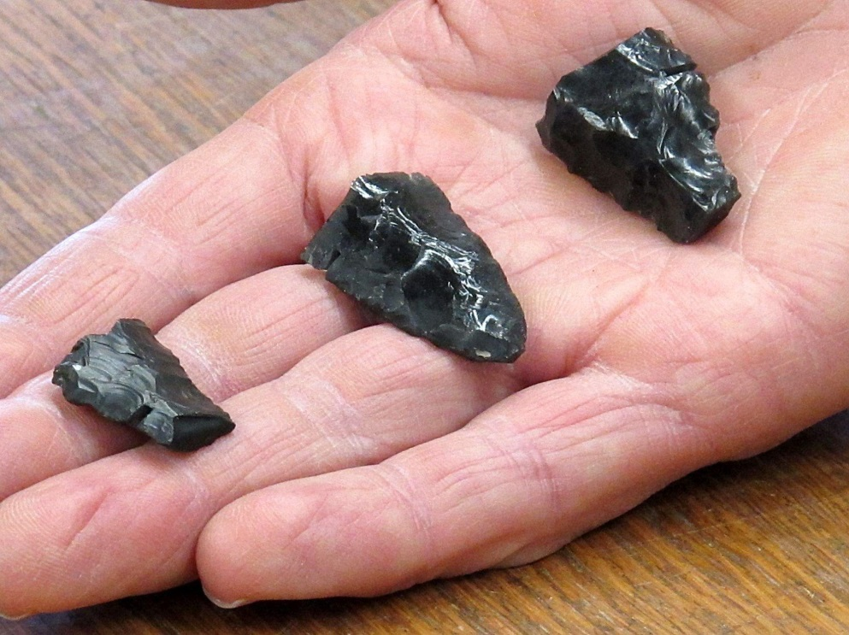
Figure 2: Stone tool fragments
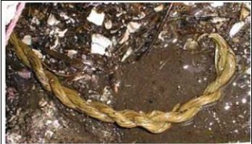
Figure 3: Cordage
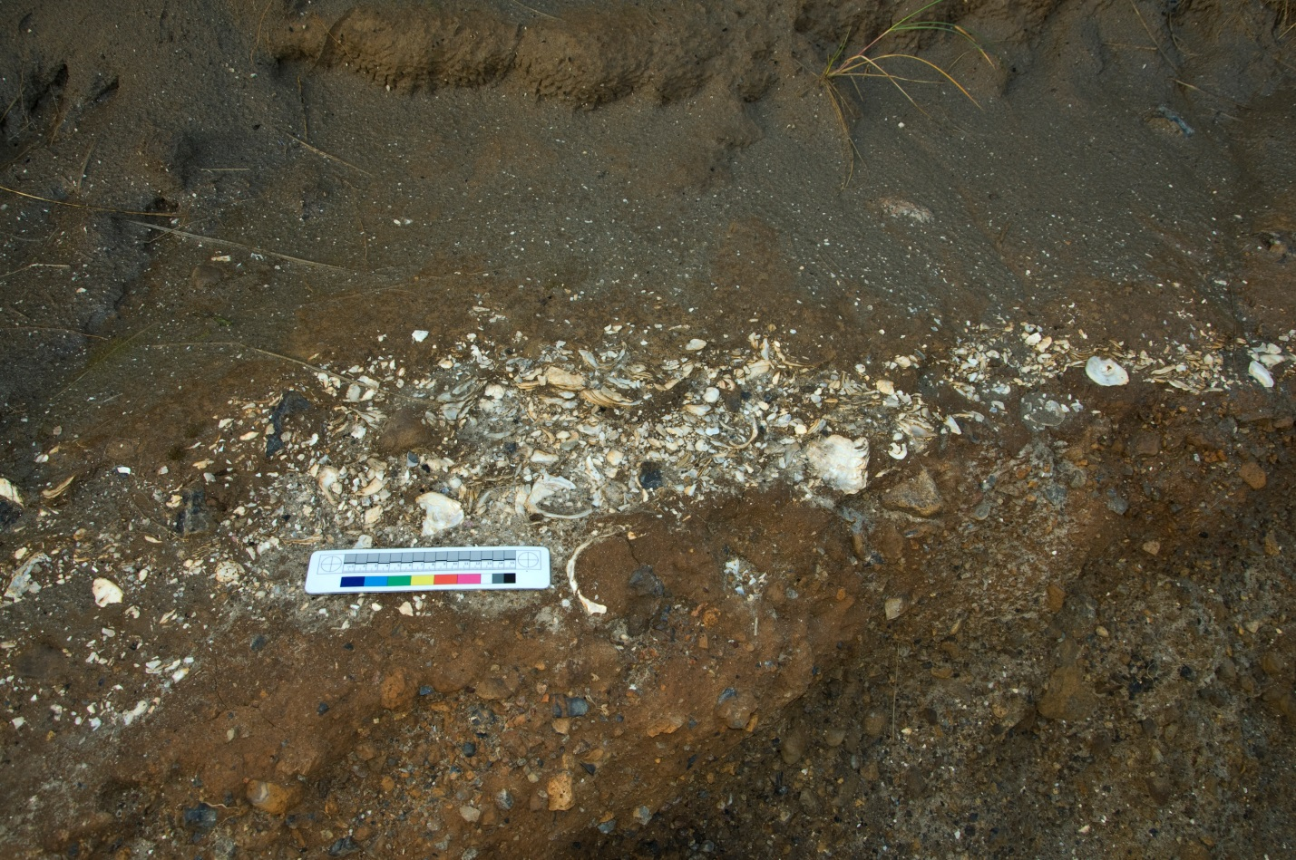Figure 4: Shell midden

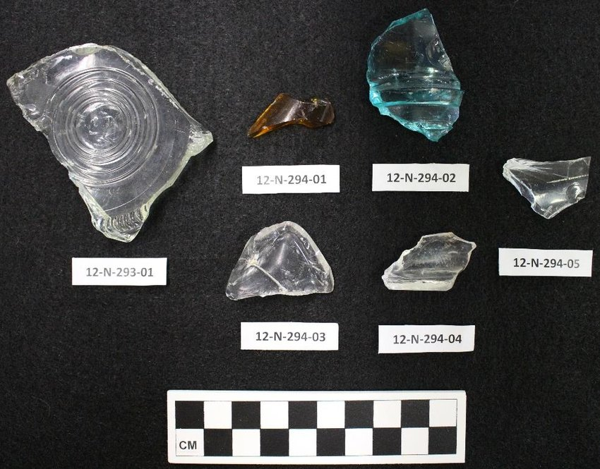
Figure 5: Historic glass artifacts
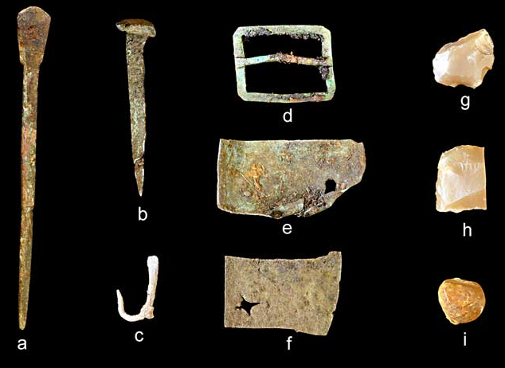
Figure 6: Historic metal artifacts

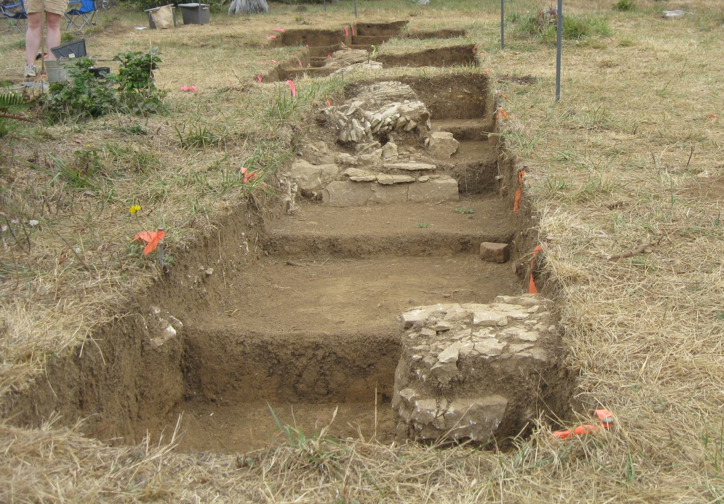
Figure 7: Historic building foundations
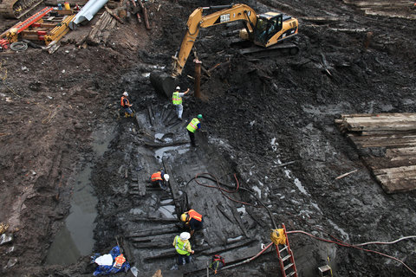
Figure 8: 18th Century ship

